Chapter 4, Problem 12.

Determine v_{o} in the circuit in Fig. 4.80 using the superposition principle.

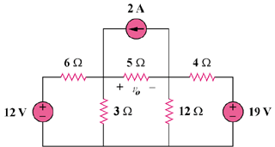

Figure 4.80
For Prob. 4.12

